**Sprint Review Meeting Report**

**Sprint 2**

**When to be held**

* At the end of this sprint 1.

**Participant Involved**

* Scrum Master (Gee Chun Seng)
* Team members (Goh Weng Yong, Chua Wei Han, Eng Yee Jei, Hamish Then Jin Jiat)
* Product owner & other stakeholders

**Purpose**

* To allows the scrum master and the team members to do a demonstration of the system to the product owner and stakeholders.
* The product owner and stakeholders will test the system and provide feedback to the scrum master and the team members.
* The system is also being demonstrated to the owners and stakeholders to check the feasibility of the system and requirement fulfilment.
* This meeting report also allows product owner and stakeholders to keep track of the development status of their system.

**Module Involved**

1. Payment Module
2. Order Module
3. Seat Reservation Module
4. Food Menu Maintenance Module

**Review User Stores Session**

**Payment Module**

|  |  |  |
| --- | --- | --- |
| **User Story** | **Status** | **Satisfied/Dissatisfied** |
| Generate receipt | Started | Satisfied |
| Calculate payment amount | Started | Satisfied |

**Order Module**

|  |  |  |
| --- | --- | --- |
| **User Story** | **Status** | **Satisfied/Dissatisfied** |
| Add order item | Started | Satisfied |
| Cancel order item | Started | Satisfied |

**Seat Reservation Module**

|  |  |  |
| --- | --- | --- |
| **User Story** | **Status** | **Satisfied/Dissatisfied** |
| Search seat | Started | Satisfied |
| Check seat | Started | Satisfied |
| Add seat | Started | Satisfied |

**Food Menu Maintenance Module**

|  |  |  |
| --- | --- | --- |
| **User Story** | **Status** | **Satisfied/Dissatisfied** |
| Search food details | Started | Satisfied |
| Update food | Started | Satisfied |
| Display food menu | Started | Satisfied |
| Delete food | Started | Satisfied |
| Add new food | Started | Satisfied |

**Customer Feedback 1**

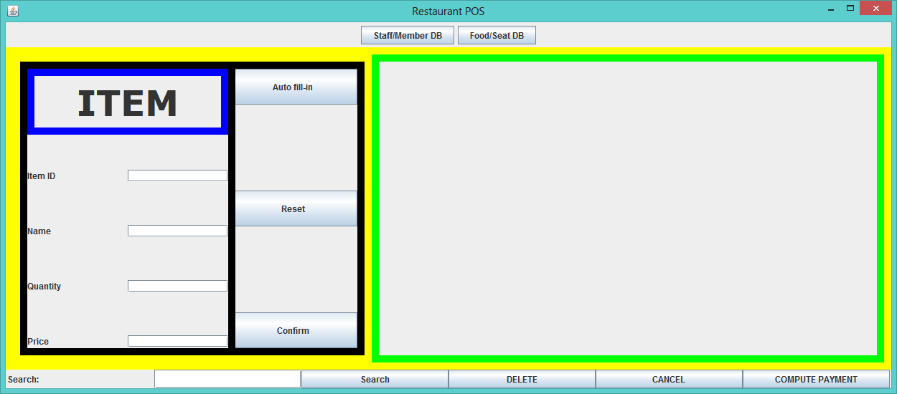

Customers complain that this user interface is ugly and dull. Customers think that the screen is not attractive enough or interesting to get their intention when making the order. They usually get confused because the user interface does not guide them how to use the system well. So, they suggest modifying the user interface more attractive so that it will be pleasant to the customer or understandable for them. Moreover, they suggest that the colour choice of the user interface can be improved as the current colour choice will give eyesore to the customer.